DIPLOMA IN PUBLIC HEALTH M。PHIL IN EPIDEMIOLOGY
_{STATISTICS AND COMPUTING}

MODELLING STRAIGHT LINE DATA：
Linear Regression
- Introduction
      - Correlation coefficients
- Model approach to regression
      - Principle of least squares
      - Line of best fit
- Hypothesis tests on model parameters
Is the slope zero?
Testing the intercept
- Confidence intervals for model parameters
- Confidence intervals for predicted responses
      - Individual response for given
Mean response for given
- ANOVA approach
      - Regression and residual sums of squares
      - 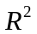measures strength of linear relationship
- Using SPSS for regression
- Assumptions
      - Checking adequacy of fit
      - Further topics
      - Non-linear, polynomial and multiple regression

Dr Chris Palmer
Centre for Applied Medical Statistics,
Dept of Public Health and Primary Care Institute of Public Health,
University of Cambridge

INTRODUCTION
Many statistical analyses aim to study the relation between a pair of variables within a group of subjects.
Correlation coefficients measure strength of (linear) association between continuous variables.
Pearson’s Product Moment
Spearman’s Rank

Correlation coefficient
yields a number from –1 to 1 to quantify association.
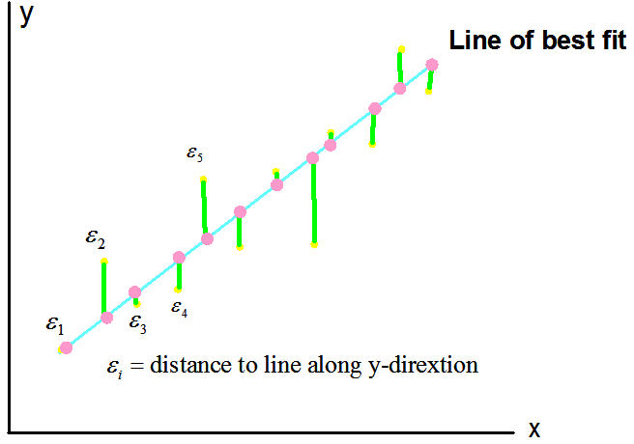

The idea of regression is to go a step further and to describe the relationship between x’s and y’s by fitting a linear model, assessing its goodness-of fit and assessing it for predictive purposes.

MODEL
Usually one variable, y, is the ‘response’ (‘dependent’) variable, while the other, x, is the ‘explanatory’ (or ‘independent’) variable. For any single observation, we model the response by:
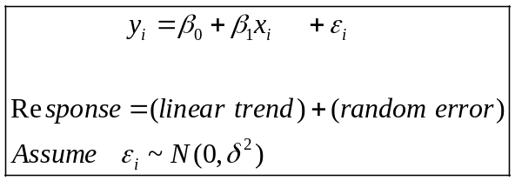
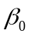 (intercept) and 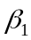 (slope) are parameters describing the line of best fit to the data.
We estimate them via a mathematical technique called ‘least squares’.
Idea: Minimise the sum of squares vertical distances between points and the line of best fit on the scatterplot.
Amounts to minimizing 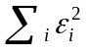 by calculus…
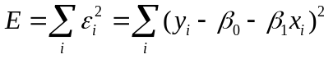
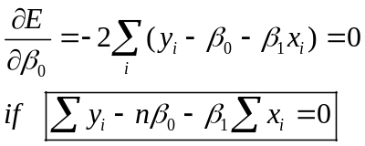 (1 )
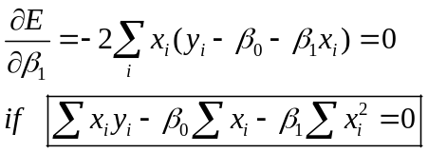 (2 )
(1) and (2) combine to yield simultaneous solutions:
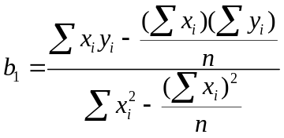
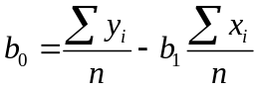
More succinctly, estimates of
by least squares
are
and
respectively
where
,
,

An important concept is that we obtain the ‘best’ straight line fit to the data, so we can describe not just how strong the relationship is between two variables, as in a correlation, but what it is: 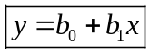
Question: how can we tell if we end up with a useful model?
Answer: In various ways.
- We can use statistical inference methods to assess whether the parameters and are significantly different from zero and/or construct confidence intervals for them.
- We can also construct C.I.’s for predicted values, either a mean response for a specified x value or a particular response for a specified x value.
- We can perform various diagnostics, e.g. plots of residuals to check model assumptions/validity.

HYPOTHESIS TESTS ON MODEL PARAMETERS
Of greatest interest is the test of
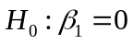 vs. 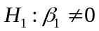
Why?
is the coefficient representing the slope of the line of best fit. If this is zero, it says the explanatory variable to be zero, we may as well model our data with a constant, 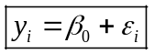

--and is estimated simply by, the mean of the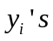. In other words, knowing the value of  for a particular observation does not help at all in explaining ( or predicting) the corresponding value of.

The ‘need to know’ standard error of estimated slope, 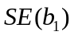:
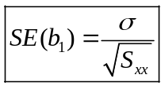
whereis itself approximated by 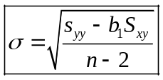 with 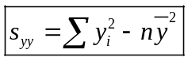
To conduct the hypothesis test, compute the test statistic:
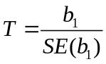 and compare with 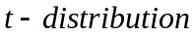 with n-2 df.
If exceeds the tabulated cutoff point, reject in favour of
The hypothesis test for, the intercept, is generally less useful, but is also found by the same test…
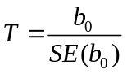
where 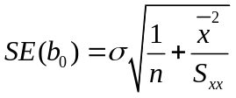
[ The good news is…all the calculations are done by computer!]

CONFIDENCE INTERVALS FOR MODEL PARAMETERS
Based on the same ideas…
95% C.I. for is 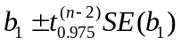
95% C.I. for is 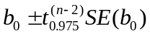

If the confidence interval includes value zero, we know automatically that the hypothesis test of, e.g., vs. is not rejected.

CONFIDENCE INTERVALS FOR PREDICTED RESPONSES

We are often interested in the confidence interval estimation of response for a specified x value.
There are two types:
- Estimate of for given
- Estimate of expected value of for given
There are for ‘particular’ value (or ‘individual’) and ‘mean response’ value respectively.
The formulate for 95% C.I.’s are necessarily wider for individual response rather than mean response.

Note: We must constrain the predicted response to the range of 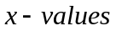 in the dataset.
ANOVA APPROACH
We can think of regression in terms of partitioning variability: that ‘explained’ by linear relationship and that which is left over, or ‘residual’.
Source | D.F. | S.S. | M.S. | F | P
Regression | 1. | 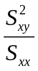 | MSR |  | …
Residual error | n-2 | 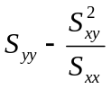 | MSE
Total | n-1 | 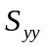

- 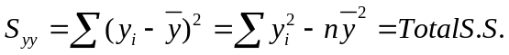
- 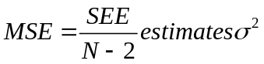
- 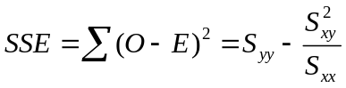 is a sum of residuals squared:
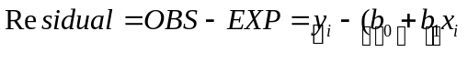
- Strength of linear relationship
=proportion of total S.S. explained by regression
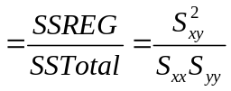
=, the square of Pearson’s correlation coefficient.

ASSUMPTIONS

Three main assumptions underpin the use of regression analysis.
- For each value of the predictor (independent) variable, X, values of the outcome (response) variable, Y, should be approximately normally distributed.
- The variability of Y, as assessed by variance or SD, should be the same (approximately constant) for each X.
- The relation between X and Y should be (approximately) linear.

Question: How do we check the plausibility of these assumptions?
Answer: Use various diagnostic plots and consider numerical statistics (MSR, , etc.) to check model adequacy.

CHECKING ADEQUACY OF FIT

- The first check is to be done before fitting linear regression, i.e. examine scatterplot to see if straight line fit is reasonable.
- Value of mean square for the residual, or its square root the standard error, gives an idea of the model’s precision.
- The value of R, or , gives a useful indication of how well the data follow a linear trend (the closer to + 1 means the better the fit).
- Graphical plots of residuals vs. observed values (or predicted) should produce a cloud of points, void of obvious patterns, either side of the ‘residual’ line.
- Histograms of residuals (standardized or not) should look ‘vaguely normal’.
Alternatively, ‘normal scores plots’ should look ‘vaguely linear’.

FURTHER TOPICS

- Non-linear regression
Inspection of the scatterplot many suggest that a straight line does not best fit the data. Sometimes, it is useful to first transform the response variable (e.g. square root, logarithm,…) and fie a straight line to the transformed data. In this case, assumptions need to be check for the newly created response variable (e.g. log’s normally distributed for given ).
- Polynomial Regression
Alternatively, we may want to fit a quadratic (or cubic…) line to the data. This is a special case of…
- Multiple Regression
…which copes with more than one explanatory variable—to be discussed next time!

SUMMARY: THREE MAIN POINTS

- Linear regression describes/models relationship between variables. It fits the straight ‘line of best fit’ through a scatterplot using the principle of least squares.
- 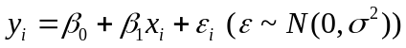
’s are parameters, subject to inference: hypothesis tests and confidence intervals (predicted/mean values too).
- Model assumptions checked via residuals.
Model adequacy checked via MSR, , etc.

